**ST.XAVIER’S COLLEGE**

MAITIGHAR, KATHMANDU



**Database Management System**

Assignment #6

Submitted By:

Aashish Raj Shrestha

013BSCCSIT002

2nd year/ 4th semester

Submitted to:

|  |  |
| --- | --- |
| Er. Anil Shah  Lecturer  Department of Computer Science |  |

1. **Statement:**

Draw an Ellipse using Mid-Point Ellipse Algorithm

1. **Algorithm:**

**Mid-Point Elliplse ( XC, YC, RX, RY):** Description: Here XC and YC denote the x – coordinate and y – coordinate of the center of the ellipse and RX and RY denote the x – radius and y – radius respectively.

1. Set RXSq = RX * RX
2. Set RYSq = RY * RY
3. Set X = 0 and Y = RY
4. Set PX = 0 and PY = 2 * RXSq * Y
5. Call Draw Elliplse(XC, YC, X, Y)
6. Set P = RYSq – (RXSq * RY) + (0.25 * RXSq) [Region 1]
7. Repeat While (PX < PY)
8. Set X = X + 1
9. PX = PX + 2 * RYSq
10. If (P < 0) Then
11. Set P = P + RYSq + PX
12. Else
13. Set Y = Y – 1
14. Set PY = PY – 2 * RXSq
15. Set P = P + RYSq + PX – PY [End of If]
16. Call Draw Elliplse(XC, YC, X, Y) [End of Step 7 While]
17. Set P = RYSq*(X + 0.5)2+RXSq*(Y – 1)2–RXSq*RYSq [Region 2]
18. Repeat While (Y > 0)
19. Set Y = Y – 1
20. Set PY = PY – 2 * RXSq
21. If (P > 0) Then
22. Set P = P + RXSq – PY
23. Else
24. Set X = X + 1
25. Set PX + 2 * RYSq
26. Set P = P + RXSq – PY + PX [End of If]
27. 27. Call Draw Ellipse(XC, YC, X, Y) [End of Step 18 While]
28. 28. Exit

**Draw Ellipse (Xc, Yc, X, Y):**

1. Call PutPixel(XC + X, YC + Y)

2. Call PutPixel(XC - X, YC + Y)

3. Call PutPixel(XC + X, YC - Y)

4. Call PutPixel(XC - X, YC - Y)

5. Exit

1. **Source Code:**

//---------------------------------------------------------------------------

#include <vcl\vcl.h>

#pragma hdrstop

#include "ELLIPSE.h"

//---------------------------------------------------------------------------

#pragma resource "*.dfm"

TForm1 *Form1;

int xc,yc,Rx,Ry;

//---------------------------------------------------------------------------

__fastcall TForm1::TForm1(TComponent* Owner)

: TForm(Owner)

{

}

//---------------------------------------------------------------------------

void __fastcall TForm1::Button1Click(TObject *Sender)

{

int x,y;

int xc,yc,Rx,Ry;

int p;

xc=StrToInt(Edit1->Text);

yc=StrToInt(Edit2->Text);

Rx=StrToInt(Edit3->Text);

Ry=StrToInt(Edit4->Text);

x=0;

y=Ry;

p=(Ry*Ry)-(Rx*Rx*Ry)+((Rx*Rx)/4);

while((2*x*Ry*Ry)<(2*y*Rx*Rx))

{

Image1->Canvas->Pixels[xc+x][yc-y]=RGB(100,0,0);

Image1->Canvas->Pixels[xc-x][yc+y]=RGB(0,200,0);

Image1->Canvas->Pixels[xc+x][yc+y]=RGB(0,0,100);

Image1->Canvas->Pixels[xc-x][yc-y]=RGB(205,55,0);

if(p<0)

{

x=x+1;

p+=(2*Ry*Ry*x)+(Ry*Ry);

}

else

{

x=x+1;

y=y-1;

p+=(2*Ry*Ry*x+Ry*Ry)-(2*Rx*Rx*y);

}

}

p=((float)x+0.5)*((float)x+0.5)*Ry*Ry+(y-1)*(y-1)*Rx*Rx-Rx*Rx*Ry*Ry;

while(y>=0)

{

Image1->Canvas->Pixels[xc+x][yc-y]=RGB(100,0,0);

Image1->Canvas->Pixels[xc-x][yc+y]=RGB(0,200,0);

Image1->Canvas->Pixels[xc+x][yc+y]=RGB(0,0,100);

Image1->Canvas->Pixels[xc-x][yc-y]=RGB(205,55,0);

if(p>0)

{

y=y-1;

p-=(2*Rx*Rx*y)+(Rx*Rx);

}

else

{

y=y-1;

x=x+1;

p+=(2*Ry*Ry*x)-(2*Rx*Rx*y)-(Rx*Rx);

}

}

}

//---------------------------------------------------------------------------

1. **Output:**

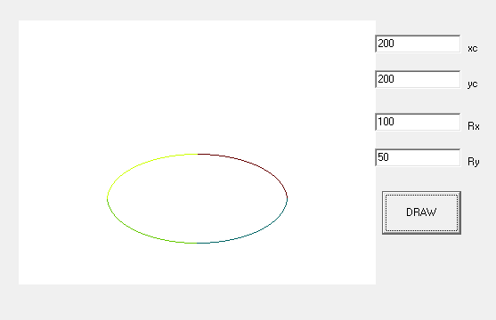

*Figure I: Implementation of Mid-point Ellipse Algorithm*

1. **Conclusion:**

Hence, mid-point ellipse algorithm was implemented to draw a ellipse using C++ Builder.